PROJECT REPORT
FOR
Foundations of Artificial Intelligence
CAREBRIDGE: HUMAN-CENTERED EMERGENCY CARE & CLASSICAL AI
A PROJECT REPORT
Submitted by
240701819 – AADHAVAN RP
240701816 – ABINESH N

October, 2026

BONAFIDE CERTIFICATE
Certified that this project report “CAREBRIDGE: HUMAN-CENTERED EMERGENCY CARE & CLASSICAL AI” is the bonafide work of “AADHAVAN RP (240701819) and ABINESH N (240701816)” who carried out the project work under my supervision.

SIGNATURE OF THE FACULTY INCHARGE

Submitted for the Practical Examination held on ____________________

SIGNATURE OF THE INTERNAL EXAMINER

TABLE OF CONTENTS
CHAPTER NO. / TITLE PAGE NO.
ABSTRACT 4
1. INTRODUCTION 5
2. LITERATURE REVIEW 7
3. PROPOSED SYSTEM 8
3.1 ARCHITECTURE DIAGRAM 8
4. MODULES DESCRIPTION 10
4.1 PATIENT AND ENCOUNTER MANAGEMENT 10
4.2 OBSERVATION MANAGEMENT 10
4.3 RISK AND ASSESSMENT 10
4.4 OPERATIONAL PRIORITIZATION 10
4.5 REQUIREMENT ENGINE 10
4.6 AI ALLOCATION AND PLANNING 10
4.7 DOCTOR, RECEPTION AND ADMINISTRATOR WORKSPACES 11
4.8 DISCHARGE MANAGEMENT 11
4.9 TIMELINE, AUDIT AND REAL-TIME SYNCHRONIZATION 11
5. IMPLEMENTATION AND RESULTS 13
5.1 EXPERIMENTAL SETUP 13
5.2 RESULTS 14
6. CONCLUSION AND FUTURE WORK 16
7. REFERENCES 18

ABSTRACT
In an emergency department, the patients, doctors, rooms, beds and equipment are always changing, and a record entered at registration soon becomes out of date. CareBridge is our academic prototype that tries to keep all of this coordinated. It stores patient observations, applies rules to assess risk and set a queue priority, works out what resources each patient needs, and then assigns doctors, rooms, beds and equipment. For the allocation and replanning we used classical AI methods: constraint satisfaction, A* search, matching, priority queues and optimization. When a doctor saves new observations and an assessment, the patient's current state, priority and alerts are recalculated, and the older observations are kept for audit. Receptionists, doctors and administrators each get their own workspace. In the reported testing, 100 automated tests and nine end-to-end scenarios passed and the production build succeeded. CareBridge is only a decision-support prototype and has not been clinically validated.

1. INTRODUCTION

1.1 Background
An emergency department has to manage patients, doctors, treatment rooms, beds and equipment all at once, and none of these stay the same for long. A patient may improve or get worse, and a bed or a doctor may become free or busy. A record made at registration, or an allocation made only once, can quickly stop being correct.
CareBridge is the software prototype we built for this course to help coordinate emergency care using classical AI. It brings together observation handling, configured rules, risk and priority assessment, resource requirements, allocation and replanning. We tried to make every operational decision traceable, while leaving the clinical assessment to the doctor.
Whenever a doctor saves new observations and an assessment, the patient’s current state, priority, alerts and resource needs are updated together. Earlier observations and decisions are not deleted, so they can still be reviewed later.

1.2 Problem Statement
Intake, reassessment, prioritization and resource allocation are often handled on separate screens or in static records, so they drift apart. A patient first marked critical may improve after treatment, while another patient may get worse. If the new observations and assessments do not reach the priority queue, alerts, dashboards and allocation logic, different users end up looking at old or conflicting information.
The problem addressed is: how can an emergency-care application keep one consistent and auditable view of each patient, and update priorities and resource plans automatically when new observations, doctor assessments or resource changes come in?

1.3 Aim and Objectives
Our aim was to build a role-based prototype for coordinating emergency care that uses classical AI for prioritization, allocation and replanning. The specific objectives were:
- To develop a role-based platform for patient registration, clinical reassessment, operational coordination and discharge workflow.
- To maintain a historical timeline of observations and clinical decisions without overwriting earlier records.
- To support rule-based assessment and operational prioritization using configured project logic.
- To evaluate patient-resource assignments against availability, compatibility, workload and configured constraints.
- To use classical AI search and optimization where appropriate for allocation and replanning.
- To propagate committed changes to patient lists, dashboards, alerts, timelines and relevant workspaces.
- To provide traceable decisions and audit history for academic demonstration and software verification.

1.4 Terminology
A few terms are used again and again in this report, and they mean different things. The system risk is what the application calculates. The doctor assessment is what the doctor saves. The operational priority is the patient’s position in the queue. Observations are the recorded readings that the other three are based on.

2. LITERATURE REVIEW
This chapter gives a short overview of the research areas that relate to our project. It is not a full systematic review, and we have avoided quoting specific findings that we have not verified.

2.1 Related Research Areas
Table 2.1 Research areas relevant to CareBridge
Research area | Common approach | Relevance / limitation
Emergency triage and prioritization | Structured protocols and scoring systems classify urgency. | A score alone does not coordinate all resources or guarantee that later updates propagate.
Clinical early-warning systems | Vital signs and trends support recognition of deterioration. | Risk scoring is not a resource plan; clinical context remains essential.
Machine-learning risk prediction | Models estimate risk from historical or current data. | Performance depends on representative data, validation, calibration and monitoring.
Constraint-based scheduling | Constraints support feasible staff, room, bed and equipment assignments. | Availability changes can invalidate previous plans.
Search and optimization | Search methods compare action sequences or allocations against a cost function. | State, objective, constraints and cost function must be explicit.
Healthcare coordination dashboards | Dashboards combine status, queues, alerts and operational information. | Multiple views can become inconsistent without a persisted source of truth.

2.2 Research Gap
Most existing work handles only one part of the problem, such as triage scoring, early warning, scheduling or dashboards. With CareBridge we tried to put patient-state updates, priority, constrained allocation, decision traces and replanning into a single prototype. This is our integration goal; we are not saying that other systems lack these features.

3. PROPOSED SYSTEM
CareBridge has a separate workspace for the receptionist, the doctor and the administrator. A patient is registered and observations are recorded. The system then calculates its own assessment and the queue priority from the configured rules, and checks what resources the patient needs. When a doctor reassesses the patient, they can save new observations along with their own assessment. The application then updates the patient’s current state, the priority queue and the alerts. If the change affects which resources are suitable, the allocation and planning components work out the plan again.
We deliberately keep four things apart: observations (the recorded readings), the system assessment (what the application calculates), the doctor assessment (the doctor’s own judgment) and the operational priority (the order in the queue). If the system and the doctor disagree, both are kept and the difference stays visible, instead of one silently replacing the other.

3.1 Architecture Diagram
Figure 3.1 shows how data moves through CareBridge. Whenever a new observation or a resource change arrives, the pipeline runs again from the assessment stage, so the plan is always based on the latest state.
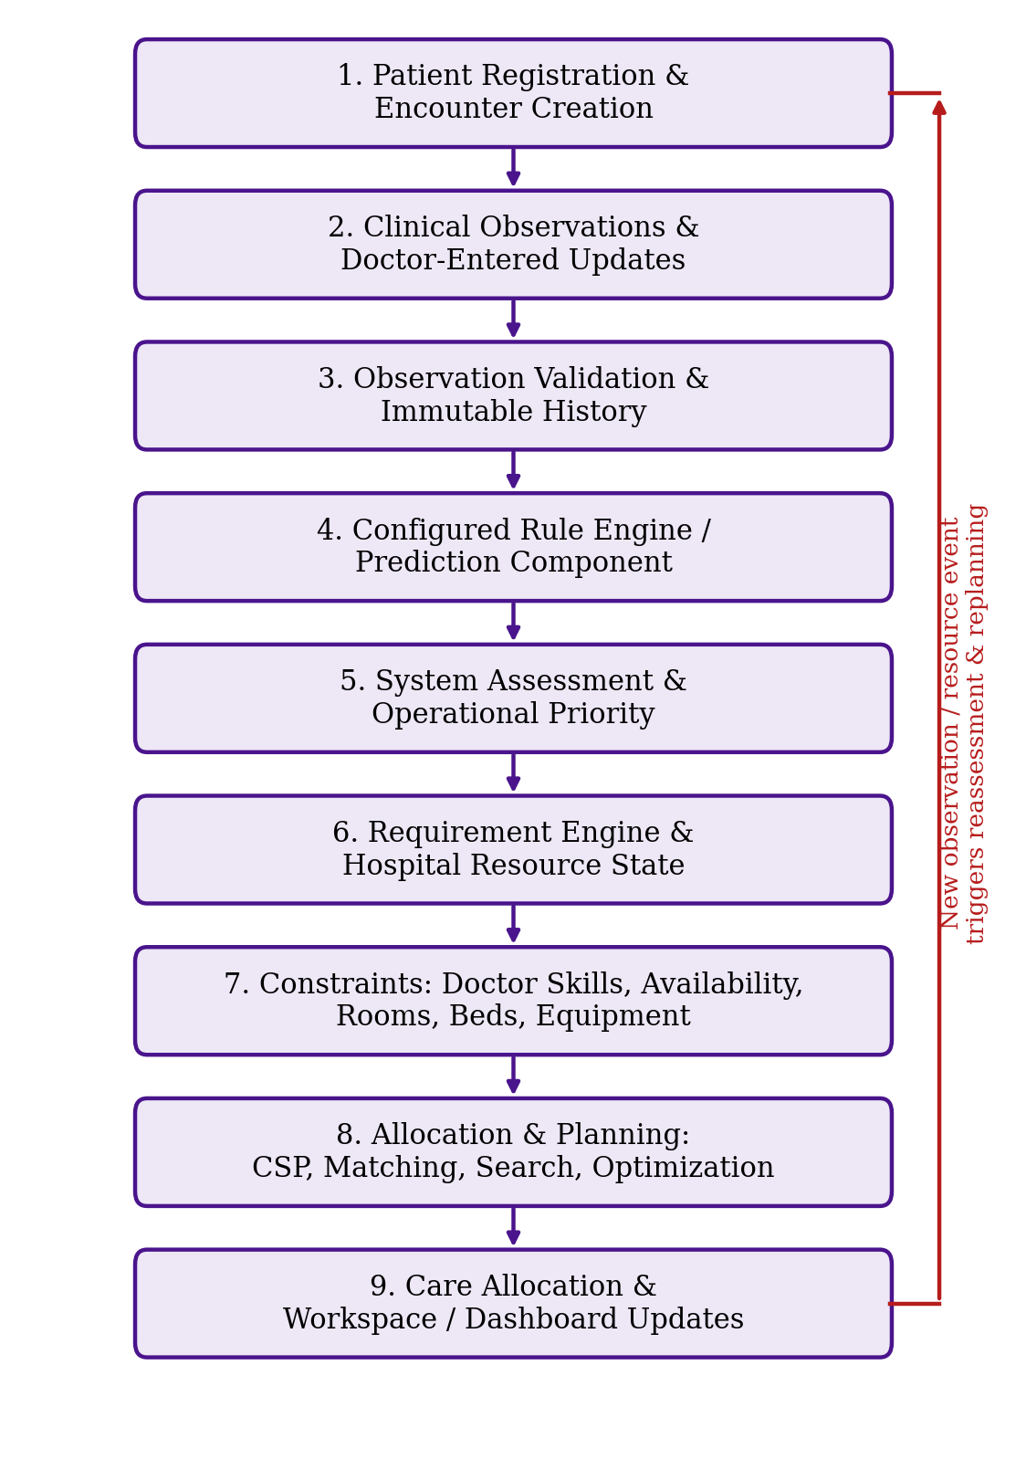
Figure 3.1 CareBridge system architecture
Architecture principle: the latest saved state in the database is the single source of truth. Changes are committed first and only then sent to the other screens as live updates. Past observations and decisions are never edited; only the current state and priority are updated.

4. MODULES DESCRIPTION
We divided CareBridge into the modules below. Each one has its own job, so a change in one place flows through the workflow instead of being copied by hand into several places.

4.1 PATIENT AND ENCOUNTER MANAGEMENT
This module registers patients, creates an encounter for each visit, stores the intake details and records whether the patient is still active or has been discharged. Observations, assessments, allocations and discharge are all linked to the encounter.

4.2 OBSERVATION MANAGEMENT
Each observation is checked and then saved as a new entry with its source and time. Older entries are never overwritten. The newest set of observations decides the patient’s current state, and the full series of entries makes up the timeline.

4.3 RISK AND ASSESSMENT
The system assessment comes from the configured rules (and from a prediction component, if one is switched on). It is stored separately from the doctor’s saved assessment, and the two are never merged without anyone noticing, so a disagreement can always be seen and audited. A risk label from the software is not a diagnosis.

4.4 OPERATIONAL PRIORITIZATION
The queue priority is worked out from the configured policy and the patient’s current state and is kept in a priority queue. It only decides the order in which work is done and is separate from the clinical assessment.

4.5 REQUIREMENT ENGINE
From the current assessment and the configured rules, this module decides what a patient needs, for example a doctor with the right skills, a room, a bed and some equipment.

4.6 AI ALLOCATION AND PLANNING
This module checks which combinations of doctor, room, bed and equipment are possible, based on availability, compatibility, workload and the other constraints. It proposes changes to the plan when conditions change. If no valid allocation exists, it says so clearly instead of making one up. The techniques it uses are described in Section 4.10.

4.7 DOCTOR, RECEPTION AND ADMINISTRATOR WORKSPACES
In the Doctor workspace, a doctor can review assigned patients, add observations, save an assessment and notes, and request discharge. The Reception workspace handles patient intake and completing the discharge, within the permissions of that role. The Administrator workspace is used to oversee operations, manage staff and resources, and view alerts, audit records and configuration, as far as implemented. Permissions are checked on the server, not just by hiding buttons on the screen.

4.8 DISCHARGE MANAGEMENT
The doctor’s request for discharge and the final completion of discharge are two separate steps. The patient stays active until an authorized user completes it, and that single action updates the encounter, the discharge record, the resources that become free and the audit trail together. If the same completion is attempted twice, the second attempt is rejected safely.

4.9 TIMELINE, AUDIT AND REAL-TIME SYNCHRONIZATION
The timeline lists the changes in risk and priority, the observations, the assessments and the actions taken. Once a database transaction is committed, the live-update mechanism sends the change to the relevant workspaces, so the patient lists, badges, dashboards and alerts all show the same current state.

4.10 ALGORITHMS AND AI TECHNIQUES
Table 4.1 Techniques used in CareBridge
Technique | Role in CareBridge
Rule-based reasoning | Applies configured conditions to observations and workflow decisions. Clinical thresholds require appropriate validation.
Priority scoring / priority queue | Orders operational work using configured priority factors; a queue score is not a diagnosis.
Constraint Satisfaction Problem (CSP) | Represents allocation requirements and hard constraints such as availability or compatibility.
A* search | Searches for a lower-cost sequence of planning actions, using a state, a goal, path cost g(n), heuristic h(n) and f(n) = g(n) + h(n).
Matching | Supports compatible assignment between patients and available staff or resources.
Greedy baseline | Selects a locally preferred feasible option quickly; it does not guarantee a global optimum.
Optimization and dynamic replanning | Reevaluates assignments when patient state, priority, availability or constraints change.
Machine learning (if enabled) | May support prediction; the model, dataset, metrics and status must be documented from actual code and experiments.

Just naming a technique here does not prove that every workflow calls it. The final submission should point to where each one is actually called, with example decision traces.

5. IMPLEMENTATION AND RESULTS

5.1 Experimental Setup
We developed and tested the prototype on Windows. The table below lists what the project needs, based on our project structure and commands. The exact versions should be confirmed from package.json before submission.
Table 5.1 Software and hardware requirements
Component | Requirement
Operating system | Windows development environment (compatibility depends on runtime and dependencies).
Runtime | Node.js and npm for backend scripts and project commands.
Frontend | React with Vite (Vite 6.4.3 appeared in the reported build output).
Backend | Node.js server/API (framework and middleware to be confirmed in backend/server.js).
Database | SQLite files referenced by the test workflow.
Browser | A modern browser supported by the frontend.
Testing | npm test; npm run build; node e2e_verification.mjs; Playwright checks.
Hardware | Development laptop or desktop with keyboard, display and network interface. No dedicated GPU is required. 8 GB RAM or more and a multi-core CPU are practical recommendations, not measured minimums.

5.1.1 Core Workflows
A. Admission and allocation. The receptionist logs in and enters the intake details and first observations. The backend validates and saves the encounter and observations, the configured logic works out the assessment and priority, and the allocation engine looks for compatible resources that are free. A successful allocation is saved and the live updates are sent after the commit. If nothing suitable is available, the system says so.
B. Doctor-led reassessment. An authorized doctor opens one of their assigned patients and records new observations and an assessment. The backend saves a new observation entry and leaves the old ones as they were. The system recalculates its own assessment and the priority, while the doctor’s assessment stays as the doctor’s judgment. The queue, badges, dashboard, alerts and resource needs are brought up to date, and a significant change can trigger replanning.
C. Discharge. The doctor records that the patient is clinically ready and submits a discharge request. The patient stays active until an authorized person completes it. That step checks the checklist and updates the encounter, discharge record, free resources and audit trail in one transaction.

5.1.2 Data Integrity and Security
- Each new observation is a new historical event with timestamp and source.
- System assessment, doctor assessment, clinical status, operational priority and reconciliation status are kept distinct.
- Multi-record allocation and discharge use transactions that roll back on failure.
- Live notifications are published only after the transaction commits.
- Role authorization is enforced on the server; passwords are stored as hashes.
- Automated tests are isolated from operational data.

5.2 Results
The results below come from our development workflow (Antigravity). We have copied them as reported and did not rerun them while writing this report.
Table 5.2 Reported verification results
Verification area | Reported result
Automated tests | 100 passed, 0 failed.
Production build | Successful; Vite production bundle completed.
Admin / reception / doctor login | Passed, including multi-doctor account isolation.
Admission and consistency | Passed, including cross-workspace consistency.
Authorization | An unauthorized doctor request returned HTTP 403.
Dynamic reassessment | Passed for observation update and reprioritization.
Discharge workflow | Doctor request followed by receptionist completion; a duplicate attempt was handled with HTTP 409.
UI quality | Zero console errors and zero failed network requests in the E2E scenario.

All nine Playwright end-to-end scenarios passed. They cover login, admission, authorization, reassessment and discharge.

5.2.1 Open Verification Point
While testing, we noticed a screenshot where the timeline showed entries that did not agree with each other, for example a “recovered” note next to DETERIORATING and P1. We still need to reproduce this, confirm that it is fixed and rerun the full test suite before we can say that everything stays fully synchronized.

5.2.2 Suggested Demonstration Flow
Table 5.3 Demonstration flow
Step | Demonstration
1 | Receptionist logs in and registers a patient with initial observations.
2 | Show initial system assessment, operational priority and resource allocation.
3 | Doctor logs in and records new observations and a saved clinical assessment.
4 | Show updated current priority, patient-list badge, dashboard and alerts.
5 | Open the timeline and show that previous observations and priority transitions remain in history.
6 | Demonstrate a resource change or an infeasible allocation, if supported.
7 | Submit a doctor discharge request and complete the administrative workflow as receptionist.
8 | Show the discharged archive and audit record.

Screenshots from the running application will be added here in the final submission.

6. CONCLUSION AND FUTURE WORK

6.1 Conclusion
CareBridge brings together patient records, doctor-led reassessment, priority handling, constrained resource allocation and dynamic planning in one academic prototype for emergency care. Our main goal was to keep the patient’s current state and every view of it in step as new observations and decisions are recorded, without losing the history or mixing up the system’s assessment with the doctor’s.
The automated tests, the production build and the end-to-end checks give reasonable evidence that the software works as intended. Before the final submission we plan to fix the priority, status and timeline inconsistency from Section 5.2.1 and rerun the whole suite.

6.2 Limitations and Ethical Considerations
- CareBridge is an academic prototype and is not clinically validated for real-world patient care.
- A software risk label or priority score is not a diagnosis and must not substitute for professional judgment.
- Clinical thresholds, rules and model outputs need review by qualified clinical stakeholders before real-world use.
- If machine learning is enabled, the dataset, validation, calibration and metrics must be documented; no performance should be claimed without evidence.
- Synthetic or demo records must be labeled and not presented as real patient outcomes.
- Privacy, access control, audit integrity and safe data handling are prerequisites for any deployment beyond a controlled demonstration.

6.3 Future Work
- Clinician-reviewed and versioned assessment and priority policies.
- Validated ML models with documented datasets, calibration, fairness analysis and monitoring, if data and approvals are available.
- More extensive concurrency tests for simultaneous admissions, observations, allocations and discharges.
- Explainability views for allocation constraints, search states, path costs and replanning decisions.
- Trend visualization for longitudinal observations and acknowledgement of significant alerts.
- Interoperability with healthcare standards and secure deployment infrastructure, subject to privacy and regulatory review.
- Formal usability evaluation and documented hazard and risk analysis.

7. REFERENCES

Gilboy, N., Tanabe, P., Travers, D., Rosenau, A.M. and Eitel, D.R. (2020) Emergency Severity Index (ESI): A Triage Tool for Emergency Department Care, Version 4, Implementation Handbook, 2020 Edition. Rockville, MD: Agency for Healthcare Research and Quality.
Hart, P.E., Nilsson, N.J. and Raphael, B. (1968) ‘A Formal Basis for the Heuristic Determination of Minimum Cost Paths’, IEEE Transactions on Systems Science and Cybernetics, Vol.4, No.2, pp.100-107.
Kuhn, H.W. (1955) ‘The Hungarian Method for the Assignment Problem’, Naval Research Logistics Quarterly, Vol.2, No.1-2, pp.83-97.
Mackworth, A.K. (1977) ‘Consistency in Networks of Relations’, Artificial Intelligence, Vol.8, No.1, pp.99-118.
Rossi, F., van Beek, P. and Walsh, T. (eds.) (2006) Handbook of Constraint Programming. Amsterdam: Elsevier.
Royal College of Physicians (2017) National Early Warning Score (NEWS) 2: Standardising the Assessment of Acute-Illness Severity in the NHS. London: RCP.
Russell, S. and Norvig, P. (2020) Artificial Intelligence: A Modern Approach, 4th edn. Harlow: Pearson.
Subbe, C.P., Kruger, M., Rutherford, P. and Gemmel, L. (2001) ‘Validation of a Modified Early Warning Score in Medical Admissions’, QJM, Vol.94, No.10, pp.521-526.

